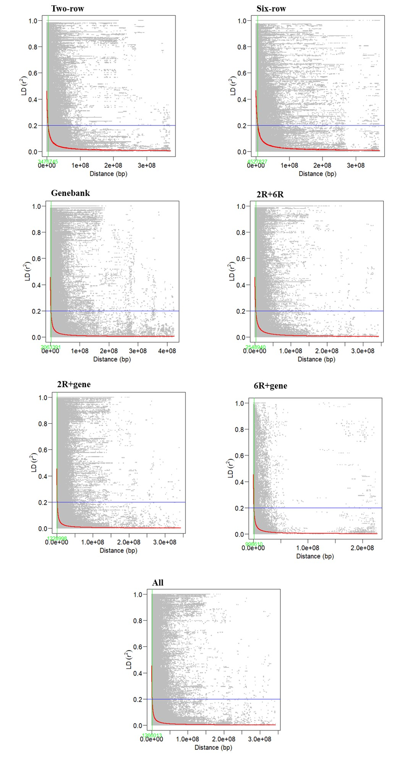
Supplementary Figure S8. Whole-genome LD decay plots for the tested single and combinations.

